ASEAN University Network /

Southeast Asia Engineering Education Development Network

AUN/SEED-Net

Implementation Guidelines
for

Collaborative Research Program with Industry (CRI)

5 | Contents of the Research
Please elaborate the following topics as clearly as possible.
5.1 Research Purpose (incl. Relevance and Justification of the proposed Project)
The Mekong Delta is a 40,000-km² region in the low stream of the Mekong river in the South of Vietnam. The Mekong river forms a system of rivers in the whole this area known as the Cuu Long river (Fig. 1). These rivers provide main system of water way transportation for the Mekong Delta, and now the need of ground transportation becomes clearly increasing. Many rural roads need to be built to serve local people, especially in the flood season. There are thirteen provinces in the Mekong Delta, and these provinces are affected by annual floods by the Mekong river from August to December yearly. The flood causes failures of rural roads and the local governments have spent high cost to repair these failures every year. Thus, it is needed that effective techniques to construct rural roads sustain annual flood impact. For this research proposal, An Giang province, one of thirteen provinces in the Mekong Delta, will be chosen for a field experiment.
Mekong Delta

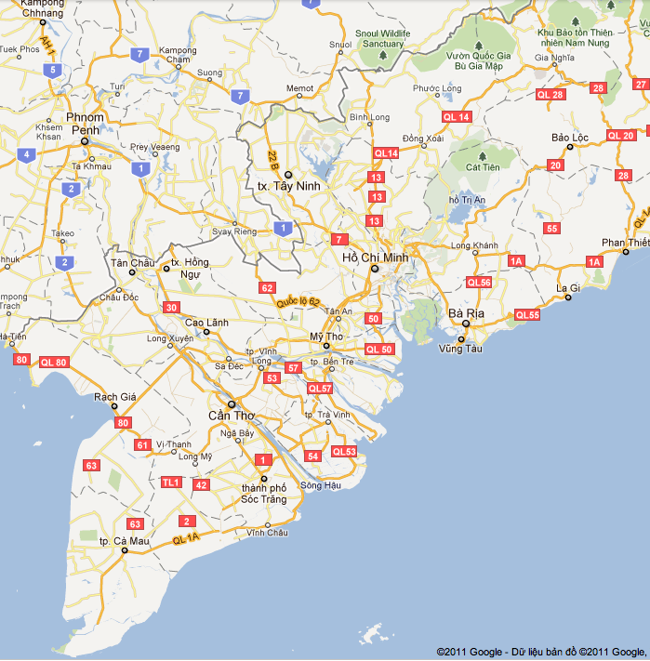
Vietnam
Cambodia
Hau River
Tien River
An Giang
Figure 1. The Mekong Delta region in the South of Vietnam (Google map)

An Giang province locates at the border between Vietnam and Cambodia in which the Mekong river reaches the Vietnam land and the Mekong river is divided into to big rivers called Hau river and Tien river. These rivers form a network of smaller rivers covering the whole province. The network of rivers provides An Giang people both advantages and disadvantages. One of negative effects of this river network on infrastructure is annual floods. The flood causes damages for rural roads such as embankment slope erosion and some sections of a road cut because the embankment of a rural road is often constructed by filling in-place soil (Fig. 2).

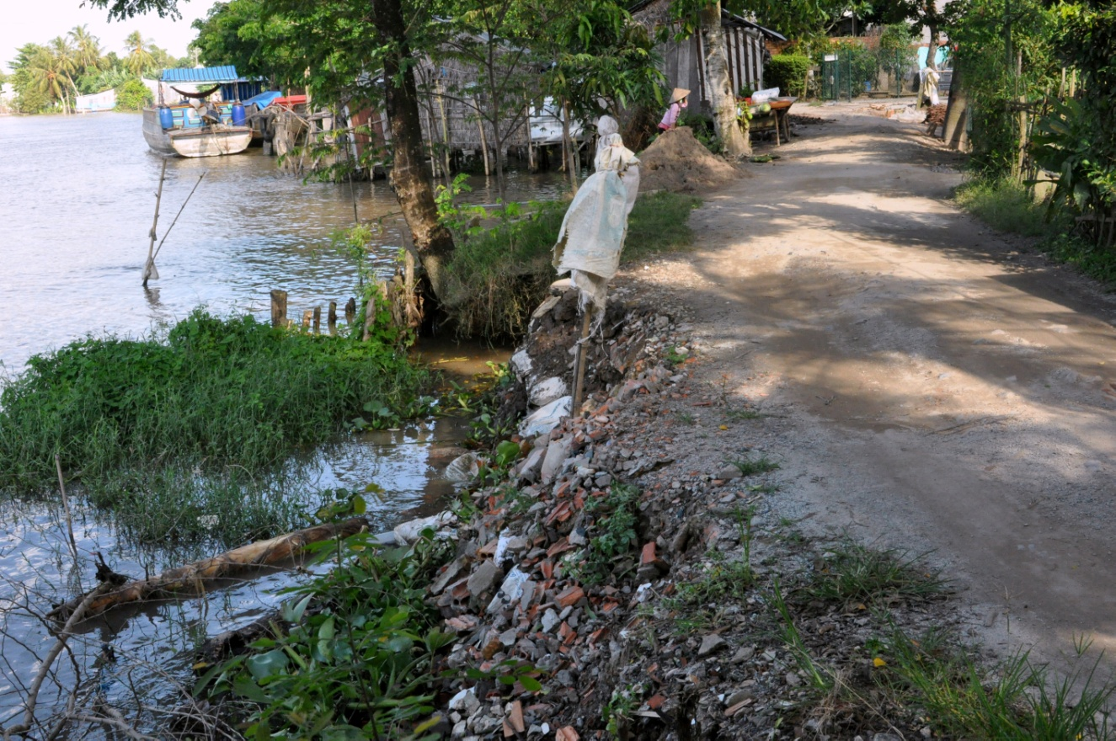
Figure 2. Some damages of a rural road due to annual floods in An Giang province

The An Giang rural transportation system is about 3,365 km and there are 1,850 km of rural roads that need to be constructed as soon as possible. The local people will be great beneficial if this rural road system can be constructed and in service. However, with the current techniques, it’ll take years to construct 1,850 km rural roads for An Giang province alone, and the rual roads built using these methods are also costly and less durable, especially with the annual floods. Therefore, an effective technology that can be applied to contruct rural roads economically and quickly is crucial for An Giang province and also for other provinces in the Mekong Delta.

The soil-cement mixing technology is a technique mixing the in-situ soil with cement to create a new material, soi-cement or soilcrete, having better engineering properties than those of the in-situ soil such as higher strength and lower hydraulic conductivity. The soil-cement deep mixing technology has been widely used in Vietnam and is providing a new soft ground improvement technique for the domestic market. This technology has advantages such as use of in-place materials and quick construction. However, the soil-cement shallow mixing (SCSM) technology has limit application in Vietnam. This technology mixes the in-situ soil of a surface layer from 0.5 to 1.0 m to produce a new material that can be used as a pavement to serve light weight traffic, e.g., trucks less than 2.5 tons. This technology is promising a versatile technology to construct rural roads in the Mekong Delta due to its fast contruction and the use of in-place soil. Another advantage for this technology is that quantity cement produced by domestic manuafacturers is redundant in the vietnam market (about 10 million tons in 2011 according to the Vietnam Cement Association). Thus, this technology is expected to provide local people a cheap rural road construction.

The motivations of this research are: (1) which technology and materials can be used to build rural roads agianst the annual floods, to construct easily, to be safe for environment, and to be cheap? (2) How the local people can apply these techniques to construct rural roads by themselves with minimal training?

To answer these above questions, this project aims at the following goals :
(1) Investigate appropriate cement contents that can mix with in-place soil in An Giang province to create expected engineering properties of soil-cement product.
(2) Study suitable thickness of soil-cement mixed (soilcrete) as pavement can support light weight traffic, e.g., 2.5-ton trucks.
(3) Construct a 500-m test section of a 3-3.5-m width rural road in An Giang to validate the soil-cement shallow mixing technology applied for rural roads in An Giang.

